ONEWAY PREC BY HAD
/STATISTICS DESCRIPTIVES HOMOGENEITY WELCH
/PLOT MEANS
/MISSING ANALYSIS.

Oneway

Notes
Output Created |  | 05-May-2019 23:31:03
Comments
Input | Active Dataset | DataSet0
Input | Filter | <none>
Input | Weight | <none>
Input | Split File | <none>
Input | N of Rows in Working Data File | 30
Missing Value Handling | Definition of Missing | User-defined missing values are treated as missing.
Missing Value Handling | Cases Used | Statistics for each analysis are based on cases with no missing data for any variable in the analysis.
Syntax |  | ONEWAY PREC BY HAD  /STATISTICS DESCRIPTIVES HOMOGENEITY WELCH  /PLOT MEANS  /MISSING ANALYSIS.
Resources | Processor Time | 00 00:00:00.172
Resources | Elapsed Time | 00 00:00:00.165

[DataSet0]

Descriptives
PREC
 | N | Mean | Std. Deviation | Std. Error
1-4 hours per day | 10 | 37.0000 | 26.68749 | 8.43933
4-8 hours per day | 6 | 65.0000 | 38.60052 | 15.75860
Less than an hour a day | 9 | 23.3333 | 16.77051 | 5.59017
More than 8 hours per day | 5 | 73.0000 | 52.86776 | 23.64318
Total | 30 | 44.5000 | 36.42067 | 6.64947

Descriptives
PREC
 | 95% Confidence Interval for Mean |  | Minimum | Maximum
 | Lower Bound | Upper Bound | Minimum | Maximum
1-4 hours per day | 17.9089 | 56.0911 | .00 | 80.00
4-8 hours per day | 24.4912 | 105.5088 | 25.00 | 125.00
Less than an hour a day | 10.4424 | 36.2243 | 5.00 | 50.00
More than 8 hours per day | 7.3560 | 138.6440 | 5.00 | 130.00
Total | 30.9003 | 58.0997 | .00 | 130.00

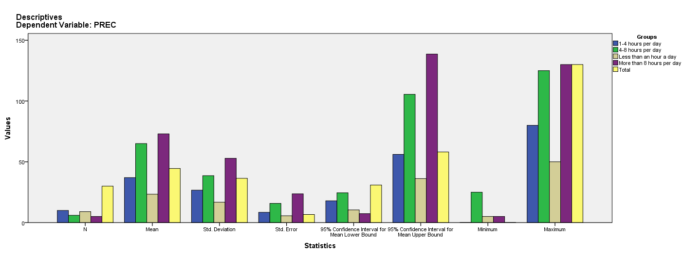

Test of Homogeneity of Variances
PREC
Levene Statistic | df1 | df2 | Sig.
3.719 | 3 | 26 | .024

ANOVA
PREC
 | Sum of Squares | df | Mean Square | F | Sig.
Between Groups | 11177.500 | 3 | 3725.833 | 3.550 | .028
Within Groups | 27290.000 | 26 | 1049.615
Total | 38467.500 | 29

Robust Tests of Equality of Means
PREC
 | Statisticª | df1 | df2 | Sig.
Welch | 2.998 | 3 | 10.403 | .080
a. Asymptotically F distributed.

Means Plots

